Information for Up-coming Parenting Courses:

Please find attached a poster for the first seminar covering Helping Children Manage Change from Parenting NI being held on Tuesday 9th March @ 7.00pm – 8.30pm.

There is also attached a url link for this session to be shared with parents in order to subscribe to the session via event bright and details will then be sent directly to the parents from parenting NI in relation to the seminar just copy and paste into a internet browser.

https://www.eventbrite.co.uk/e/helping-children-manage-change-derry-londonderry-primary-schools-tickets-141017048789
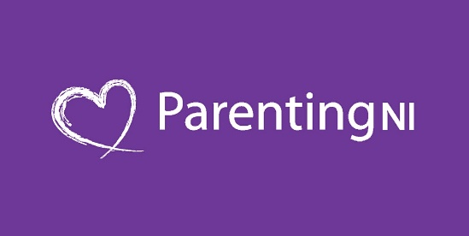 | Helping Children Manage Change - Derry-Londonderry Primary Schools  Helping Children Manage Change  www.eventbrite.co.uk

There are 2 more courses from Parenting NI to follow:
Keeping Children Safe Online being held on Tuesday 16th March @ 7.00pm – 8.30pm.
Resolving Conflict in the Home being held on Tuesday 23rd March @ 7.00pm – 8.30pm.

The link to these courses will be forwarded closer to the events.

Just to remind you that Part 2 of the Bronagh Starrs course is on this Thursday,25th February @7pm.

