Spelling Sheet |  |  |  |  |  |  |  |  | long e - ea sound
Use the spelling list for the following activities.
Unjumble these spellings
 |  |  |  |  |  |  |  |  |  |  |  |  | airport
hang tiny |  |  |  |  |  |  |  |  | hydra bit |  |  |  | anything
a crept |  |  |  |  |  |  |  |  | wed knee |  |  |  | birthday
fuel rosy |  |  |  |  |  |  |  |  | boydryeve |  |  |  | carpet
cuba drop |  |  |  |  |  |  |  |  | Mr Ho woke |  |  |  | cupboard
 |  |  |  |  |  |  |  |  |  |  |  |  | daydream
 |  |  |  |  |  |  |  |  |  |  |  |  | everyday
Finish the compound words |  |  |  |  |  |  |  |  |  |  |  |  | forget
home |  |  |  |  |  |  |  |  |  | port |  |  | everybody
cup |  |  |  |  |  |  |  |  |  | body |  |  | homework
under |  |  |  |  |  |  |  |  |  | bow |  |  | rainbow
some |  |  |  |  |  |  |  |  |  | day |  |  | understand
 |  |  |  |  |  |  |  |  |  |  |  |  | weekend
Find your spellings in the wordsearch |  |  |  |  |  |  |  |  |  |  |  |  | something
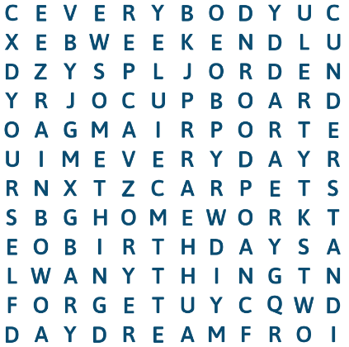 |  |  |  |  |  |  |  |  |  |  |  |  | yourself
 |  |  |  |  |  |  |  |  |  |  |  |  | See it right
 |  |  |  |  |  |  |  |  |  |  |  |  | Circle the correct spelling
 |  |  |  |  |  |  |  |  |  |  |  |  | red | rede
 |  |  |  |  |  |  |  |  |  |  |  |  | again | agian
 |  |  |  |  |  |  |  |  |  |  |  |  | allways | always
 |  |  |  |  |  |  |  |  |  |  |  |  | every | evry
 |  |  |  |  |  |  |  |  |  |  |  |  | mother | muther
 |  |  |  |  |  |  |  |  |  |  |  |  | anofer | another
 |  |  |  |  |  |  |  |  |  |  |  |  | father | faher
 |  |  |  |  |  |  |  |  |  |  |  |  | shoud | should
 |  |  |  |  |  |  |  |  |  |  |  |  | woud | would
 |  |  |  |  |  |  |  |  |  |  |  |  | gave | gaev
 |  |  |  |  |  |  |  |  |  |  |  |  | found | fuond

Spelling Sheet |  |  |  |  |  |  |  |  | long e - ea sound
Use the spelling list for the following activities.
Unjumble these spellings
 |  |  |  |  |  |  |  |  |  |  |  |  | airport
hang tiny |  | anything |  |  |  |  |  |  | hydra bit | birthday |  |  | anything
a crept |  | carpet |  |  |  |  |  |  | wed knee | weekend |  |  | birthday
fuel rosy |  | yourself |  |  |  |  |  |  | boydryeve | everybody |  |  | carpet
cuba drop |  | cupboard |  |  |  |  |  |  | Mr Ho woke | homework |  |  | cupboard
 |  |  |  |  |  |  |  |  |  |  |  |  | daydream
 |  |  |  |  |  |  |  |  |  |  |  |  | everyday
Finish the compound words |  |  |  |  |  |  |  |  |  |  |  |  | forget
home |  |  |  |  |  |  |  |  |  | port |  |  | everybody
cup |  |  |  |  |  |  |  |  |  | body |  |  | homework
under |  |  |  |  |  |  |  |  |  | bow |  |  | rainbow
some |  |  |  |  |  |  |  |  |  | day |  |  | understand
 |  |  |  |  |  |  |  |  |  |  |  |  | weekend
Find your spellings in the wordsearch |  |  |  |  |  |  |  |  |  |  |  |  | something
 |  |  |  |  |  |  |  |  |  |  |  |  | yourself
 |  |  |  |  |  |  |  |  |  |  |  |  | See it right
 |  |  |  |  |  |  |  |  |  |  |  |  | Circle the correct spelling
 |  |  |  |  |  |  |  |  |  |  |  |  | red | rede
 |  |  |  |  |  |  |  |  |  |  |  |  | again | agian
 |  |  |  |  |  |  |  |  |  |  |  |  | allways | always
 |  |  |  |  |  |  |  |  |  |  |  |  | every | evry
 |  |  |  |  |  |  |  |  |  |  |  |  | mother | muther
 |  |  |  |  |  |  |  |  |  |  |  |  | anofer | another
 |  |  |  |  |  |  |  |  |  |  |  |  | father | faher
 |  |  |  |  |  |  |  |  |  |  |  |  | shoud | should
 |  |  |  |  |  |  |  |  |  |  |  |  | woud | would
 |  |  |  |  |  |  |  |  |  |  |  |  | gave | gaev
 |  |  |  |  |  |  |  |  |  |  |  |  | found | fuond

