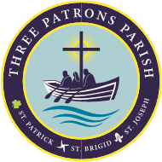
P4 Sacramental Preparation: ‘Do This in Memory’
St Patrick’s Primary School in
St Patrick’s Church, Pennyburn:
St Patrick’s Primary School- 12.15PM MASS
Please find a list of dates for the Sundays when we will celebrate the First Communion programme at the 12.15am Mass in St Patrick’s Church. This is an important part of preparation for the sacraments and we would encourage family members to attend. Children from the various P4 classes will lead the masses throughout the year.

- Sunday 1st October 2023- Enrolment Mass
- Sunday 22nd October 2023
- Sunday 19th November 2023
- Sunday 10th December 2023
- Sunday 14th January 2024
- Sunday 25th February 2024
- Sunday 24th March 2024- Palm Sunday
- Sunday 2nd June 2024 – Feast of Corpus Christi.

First Holy Communion Date:
St Patrick’s Primary School: Friday 19th April 2024 – 12pm & 2pm

