**Numeracy**

This term we will be:

* Learning the Number stories

1-10.

* Counting and ordering numbers up to100.
* Identifying odd and even numbers up to 100.
* Adding and taking away to 100 using our 100 square.
* Buying items at the garden centre shop and café using the coins –20p, 10p, 5p, 2p, and 1p.
* Finding the total cost and giving change from 10p and 20p.
* Weighing items at the flowers shop and developing the language associated with weight.
* Recognising digital time - o’clock and half past times.

**Primary 2**

**News letter**

**Spring in the garden**

**Literacy**

This term we will be:

* Revising linguistic phonics stage 4 words.
* Introducing your child to stage 5 of our linguistic phonics programme.
* Reading and sequencing the events in the story of Jack and the Beanstalk.
* Creating a story plan and using our plan to write our own Jack and the Beanstalk story.
* Writing instructions to complete a task.
* Using capital letters and full stops in our writing.
* Continuing to write the letters of the alphabet correctly.

.

[](http://www.google.co.uk/url?sa=i&rct=j&q=&esrc=s&frm=1&source=images&cd=&cad=rja&uact=8&docid=7yKkHfgjpLIWrM&tbnid=UaZ7rQticKdQzM:&ved=0CAUQjRw&url=http://photosynthesis123.wordpress.com/about/&ei=zuZMU4dgkI7tBrz6gIAL&bvm=bv.64764171,d.ZGU&psig=AFQjCNGmqEz080Lv4VBiv9CeFhsWWLUN8w&ust=1397635065566318)

**Topic Work**

We will be researching and discussing:

* Spring in the garden.
* The names of spring flowers.
* How to plant a seed.
* The parts of a flower
* How living things survive.
* Ways to reduce, reuse and recycle.

[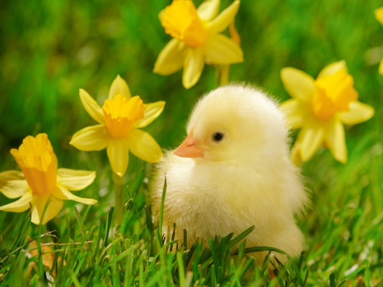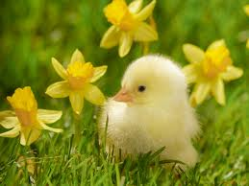](http://www.google.co.uk/url?sa=i&rct=j&q=&esrc=s&frm=1&source=images&cd=&cad=rja&uact=8&docid=QcqUWVf3egP5ZM&tbnid=TfBD_ZxFIeqyoM:&ved=0CAUQjRw&url=http://hqworld.net/gallery/details.php?image_id=21590&sessionid=088779add2d170b813cd4007b0997c17&ei=gOdMU_qbEZKA7QbFo4BY&psig=AFQjCNHVfKfO6IlAcZcSUU_2OwXWcTD2bw&ust=1397635291800241)

**Please send in any old artificial and real flowers, bulbs and seeds for planting. Thank you.**

**How can you help your child**

* Please continue to practise initial sounds especially the vowel sounds using sound book.
* Sound out and read words in word book.
* Please continue to encourage neat presentation and handwriting using our writing scheme in your child’s written homework.
* Daily homework includes reading, learning spellings and learning number stories 1-5.