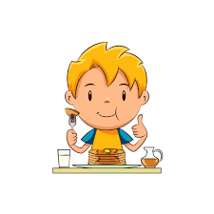
BREAKFAST
8.15am – 8.45
£1 PER CHILD FOR ANY 3 ITEMS
FROM LIST BELOW

CEREAL
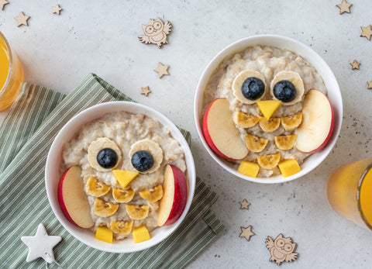
RICE KRISPIES
CORNFLAKES
WEETABIX
CHEERIOS
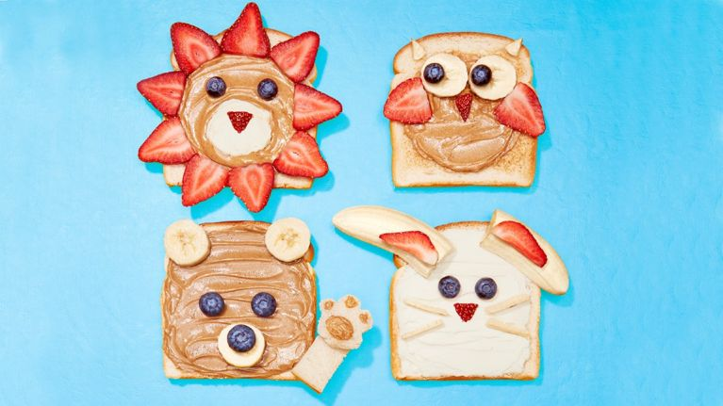
BUTTERED SCONE
BUTTERED PANCAKE
BUTTERED TOAST

DRINKS
TEA
APPLE JUICE / ORANGE JUICE
BOTTLE WATER

